Here’s a clear, classroom-ready deep explanation of the Linux file system structure—focused on understanding, real-world usage, and interview clarity.

🐧 Linux File System Structure (FHS)
Linux follows a standard called the Filesystem Hierarchy Standard (FHS).
👉 Everything starts from a single root directory:
/
This is called the root directory (not to be confused with the root user).

🌳 Overall Structure (High-Level View)

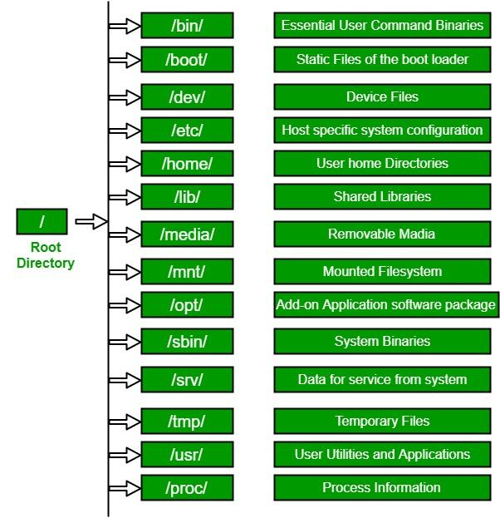

🔑 Important Directories Explained

🔹 / (Root Directory)
👉 The top-level directory
👉 All other directories exist inside this

🔹 /home
👉 User personal directories
Example:
/home/user1
/home/devops
👉 Stores:
- Documents
- Downloads
- User-specific configs

🔹 /root
👉 Home directory of the root user
- Different from /home
- Only accessible by admin

🔹 /bin
👉 Essential user commands (binaries)
Examples:
ls, cp, mv, cat
👉 Required for basic system functionality

🔹 /sbin
👉 System binaries (admin commands)
Examples:
reboot, shutdown, fdisk
👉 Mainly used by root user

🔹 /etc
👉 Configuration files
Examples:
/etc/passwd # user info
/etc/ssh/sshd_config
/etc/nginx/nginx.conf
👉 Think of it as system settings center

🔹 /var
👉 Variable data (changes frequently)
Examples:
/var/log # logs
/var/lib # application data
/var/spool # mail/print queues
👉 Very important for debugging

🔹 /tmp
👉 Temporary files
- Cleared automatically (on reboot or periodically)
- Used by apps during execution

🔹 /usr
👉 User utilities and applications
Subfolders:
/usr/bin # user commands
/usr/sbin # admin commands
/usr/lib # libraries
/usr/share # shared data
👉 Most installed software lives here

🔹 /lib and /lib64
👉 System libraries
- Required by /bin and /sbin
- Like shared code used by programs

🔹 /opt
👉 Optional / third-party software
Examples:
/opt/tomcat
/opt/custom-app
👉 Used for manual installations

🔹 /boot
👉 Boot-related files
Examples:
- Kernel
- Bootloader files (GRUB)
👉 System cannot start without this

🔹 /dev
👉 Device files
Examples:
/dev/sda # disk
/dev/null # null device
/dev/tty # terminal
👉 Hardware is treated like files in Linux

🔹 /proc
👉 Virtual file system (process info)
Examples:
/proc/cpuinfo
/proc/meminfo
👉 Provides real-time system information

🔹 /sys
👉 Interface to kernel and hardware
- Used for system tuning and device interaction

🔹 /mnt
👉 Temporary mount points
Example:
/mnt/data

🔹 /media
👉 Auto-mounted devices
Examples:
- USB drives
- CD/DVD

🧠 Easy Analogy
Think of Linux like a company building:
Directory | Analogy
/ | Building entrance
/home | Employee desks
/root | CEO cabin
/etc | Policy documents
/var | Activity logs
/bin | Basic tools
/usr | Departments
/tmp | Temporary workspace

⚠️ Important Concepts

🔥 Everything is a File
In Linux:
- Files
- Directories
- Devices
- Processes
👉 Everything is treated as a file

🔥 No Drive Letters
❌ No C:, D: like Windows
✅ Single unified structure starting from /

🔥 Mounting
Storage devices are attached to directories:
/mnt
/media

🚀 Real DevOps Usage

🔹 Debugging logs
cd /var/log

🔹 Editing configs
cd /etc/nginx

🔹 Deploying apps
cd /opt

🔹 Checking binaries
which nginx

🔚 Quick Interview Summary
👉 "Linux follows the Filesystem Hierarchy Standard where everything starts from root (/). Key directories include /etc for configuration, /var for logs, /home for user data, /usr for applications, and /bin for essential commands."

